※ 本 系 統 不 找 鈔，請 投 入 剛 好 金 額! 投 入 金 額 後 則 無 法 取 消!
The machine will not make changes. Please insert the exact amount!
Cannot cancel after the amount is invested.
※ 冷氣卡片購買或儲值後不退費，請依個人需求投入金額
The air-conditioning card will not be refunded after purchase or stored value,
please input the amount according to individual needs.
前 端 操 作 流 程Operating Procedure
※購買卡片，每張100元(含面額50元，製卡費50元)
請投入剛好金額(只限紙鈔) 請領取卡片、收據。
※ Purchase card, $ 100 per card. ($ 50 denomination,$ 50 card fee )
The machine will not make changes. Please insert the exact amount(bill only).
Please receive the card and receipt.
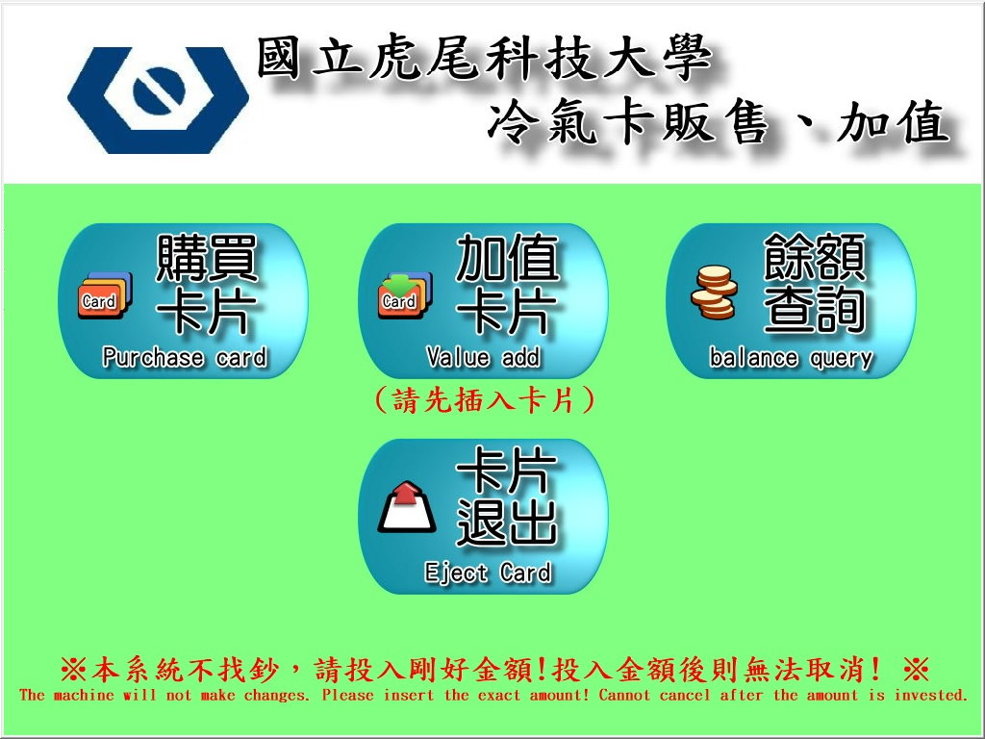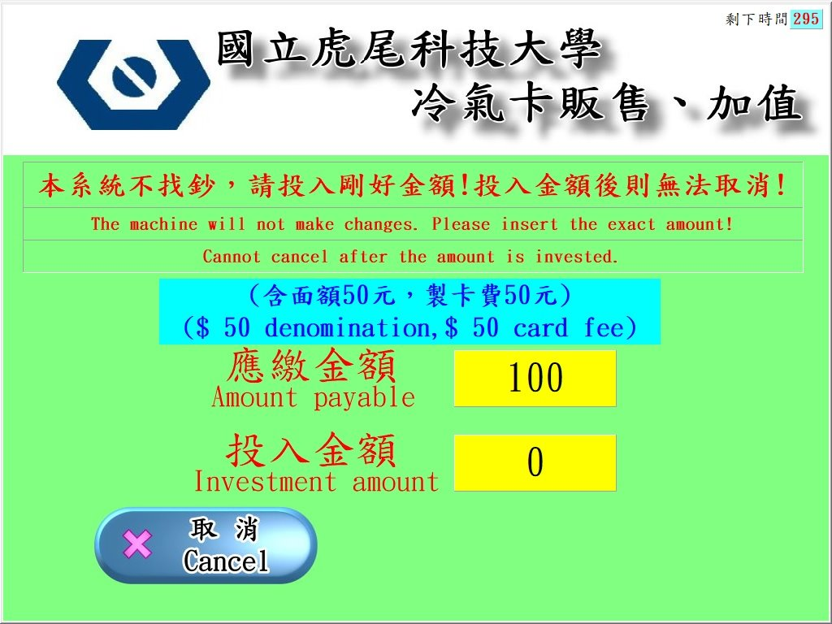
※加值卡片 ，請先插入卡片 請投入欲儲值金額後，按確定(以百元為單位，只限紙鈔) 請領取收據 卡片退出。
※Add Value Please insert the card Please insert the bill into the machine,then press Enter Please receive the receipt card exit.
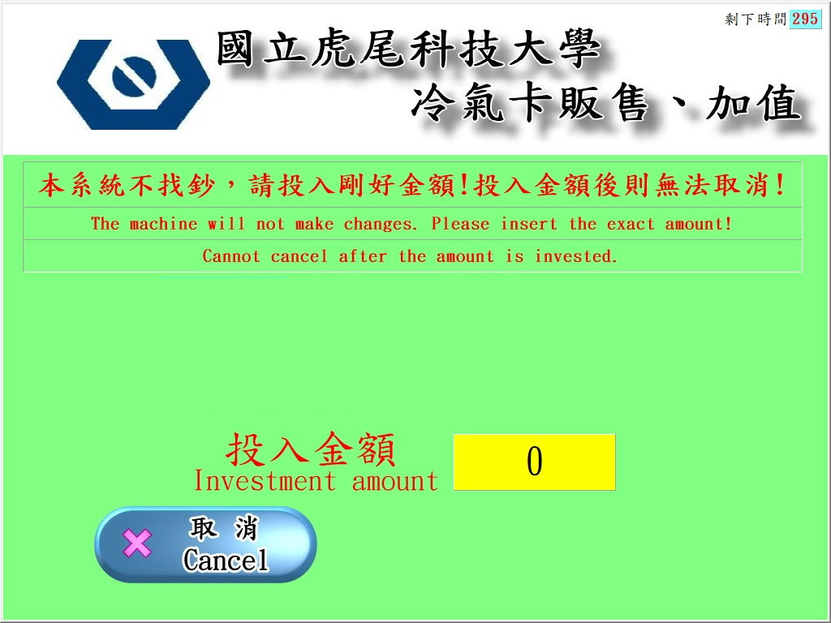
※餘額查詢 ，請先插入卡片，按確定 查詢完畢，卡片退出
※ Balance check Please insert the card and press enter.
Check is completed, card exit.
